**Washing Protocol for *Drosophila* Vials and Bottles**

**Introduction**

Reusing Drosophila vials and bottles is an important part of the Raff Lab’s efforts to reduce plastic waste. Each vial can typically be reused over 20 times, and bottles even longer, preventing thousands of items from being incinerated every year. This protocol outlines the safe and sustainable washing process.

**Materials and Equipment**

**Containers and Storage**

* Designated collection container for used vials and bottles
* Polybags for storing clean vials and bottles

**Cold Storage**

* Freezer capable of −20 °C (or −70 °C)

**Flug Handling**

* Mesh laundry bags
* Washing machine with a delicate cycle (30 °C, slow spin)
* Unscented fabric softener
* General waste bin for low-temperature incineration

**Soaking and Cleaning**

* Tap water supply
* Concentrated disinfectant (Final concentrations-0.2%)
* Beakers for collecting food waste with water
* Spatulas for scraping food and debris
* **Bottle brush for removing pupae or food stuck to bottle walls**

**Waste Disposal**

* Laboratory-dedicated blender for fly food slurry
* Sink with running water

**Dishwasher and Drying**

* Dishwasher programmable to 60 °C for 30 min
* Aluminium or plastic fly trays
* Metal mesh to secure upright trays
* Drying oven (80 °C, 60 min capacity)

**Protocol**

**1. Collection**  
Collect used Drosophila vials and bottles—either polypropylene (autoclavable) or polystyrene (clear, non-autoclavable)—in a designated container until full.

**2. Freezing**  
Freeze at −20 °C for at least 48 h, or −70 °C for at least 24 h, to eliminate flies and mites at all stages.

**3. Thawing**  
Allow frozen vials and bottles to thaw at room temperature for at least 2 h.

**4. Flug Removal**  
Remove flugs. Either:

* Wash in mesh laundry bags on a quick delicate cycle (30 °C, slow spin) with unscented softener, then air-dry at room temperature. Reuse if they still fit securely.
* Or dispose of via general waste for low-temperature incineration.

**5. Soaking**  
Soak vials and bottles overnight in tap water with 0.2% disinfectant at room temperature to soften food and organic matter.

**6. Removal of Organic Waste**  
Scrape softened food and debris (including pupae, eggs, larvae) with a spatula. Collect in a beaker with water, blend into a slurry using a laboratory-dedicated blender, and dispose of down the sink with copious running water. This route is environmentally preferable, as the waste enters sewage treatment and is converted into biogas/biofuel. *(Use a bottle brush if pupae remain stuck on bottle walls.)*

**7. Dishwasher Washing and Drying**

* Arrange vials/bottles upright on aluminium or plastic fly trays; place other trays face down.
* Secure upright trays with a metal mesh.
* Wash at 60 °C for 30 min.
* Drain excess water by inverting trays, then dry at 80 °C for 60 min.
* Finally, allow items to air-dry at room temperature.

**8. Reuse**  
Clean vials and bottles are ready to refill with fly food or can be stored in polybags to prevent contamination.

* Polypropylene/polystyrene vials last for >20 reuse cycles with careful handling.
* Bottles usually last longer.
* Stop reusing when cracks, cloudiness, or loss of transparency appear.
* Recycle damaged items if accepted by your waste collector.

**Time Requirement**

* Processing 100 vials ≈ 30 min
* Processing 100 bottles ≈ 90 min

**Why This Matters**

Reusing vials and bottles reduces plastic consumption, lowers costs, and avoids unnecessary incineration. Food waste is diverted into the sewage system where it is converted into biogas and biofuel, supporting renewable energy production. Together, these steps make fly research more sustainable while saving thousands of items from disposal every year.

*“The Raff Lab: turning 1% recycling into 99% reuse and recycling, with just 1% incinerated.”*

♻️ **85% Reused** | 🔄 **14% Recycled** | 🔥 **1% Incinerated**

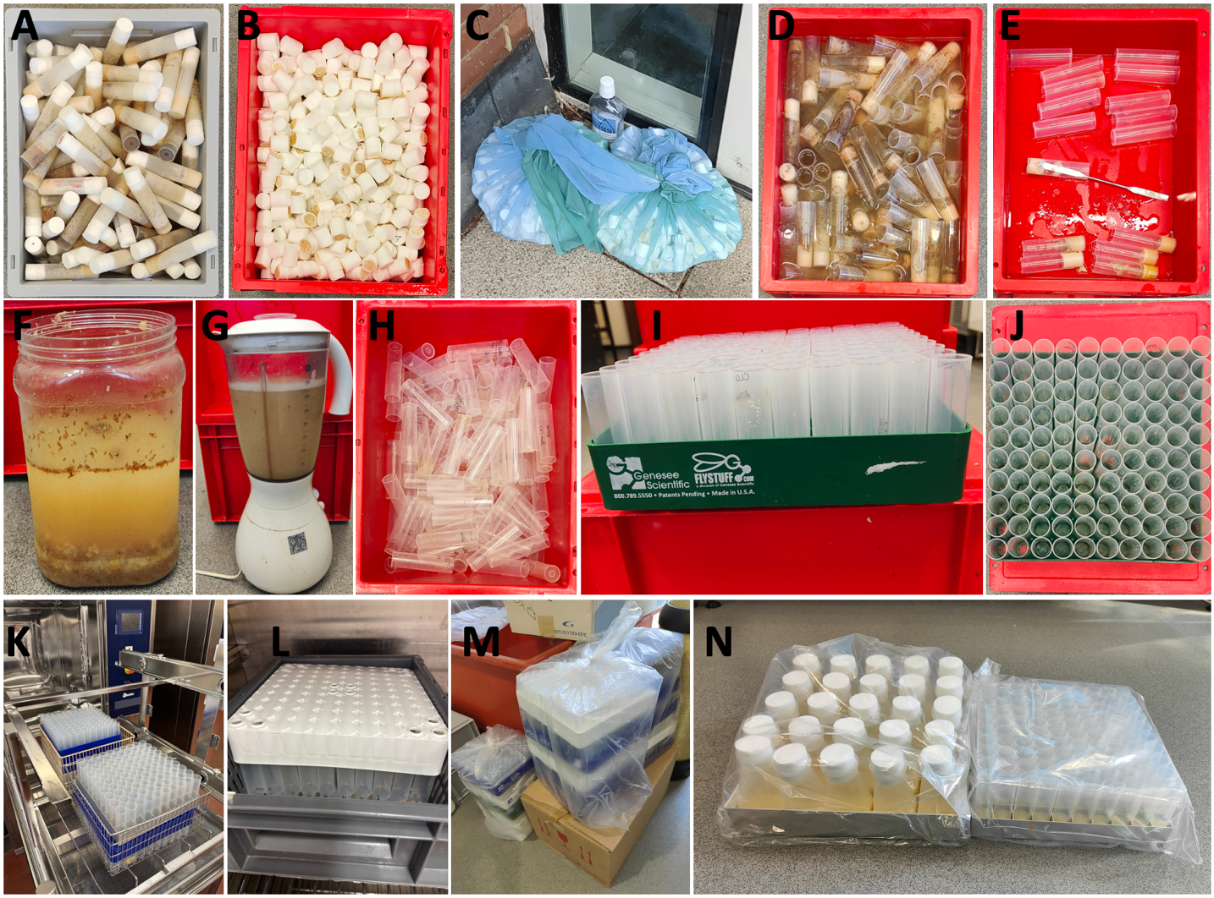

**Figure. Images showing step-by-step protocol for washing and reusing plastic (polypropylene or polystyrene) fly vials in the Raff Lab, Sir William Dunn School of Pathology, University of Oxford.**  
**(A)** Used vials with celluloid flugs are collected and frozen. **(B)** Flugs are separated for either washing or disposal. **(C)** For reuse, flugs are placed in mesh laundry bags and washed in a washing machine on a delicate 30 °C cycle with unscented fabric conditioner before being air-dried. **(D)** Vials are soaked in 0.2% Chemgene solution overnight without the flugs. **(E)** Residual fly food is scraped out with a spatula or bottle brush. **(F)** The collected waste is stored in a container. **(G)** The waste is blended into a slurry using a laboratory-dedicated blender before disposal through the sewage system, where it contributes to biogas and biofuel production. **(H)** Vials with food removed appear clean. **(I)** Clean vials are arranged in trays from the side view. **(J)** Clean vials are also arranged from the top view, ready for dishwasher washing. **(K)** Trays of vials are loaded into the dishwasher and washed at 60 °C for 30 minutes. **(L)** Washed vials are dried upside down at 80 °C for 60 minutes before being allowed to air-dry fully at room temperature. **(M)** Clean vials are stored in trays sealed with polyethylene bags to prevent contamination. **(N)** Clean bottles (shown here) and vials are refilled with fly food for reuse.

Processing 100 vials takes approximately 30 minutes. The estimated breakdown is: freezing 2.5 minutes; soaking in water and Chemgene 5 minutes; scraping out food 15 minutes; arranging in trays 3 minutes; and dishwasher washing and drying about 4.5 minutes. The same process applies to fly bottles, although times are longer (about 90 minutes for 100 bottles, with scraping and soaking taking proportionally more time).